Historic Huguenot Street Presents:
Indigenous Woodsplint Baskets
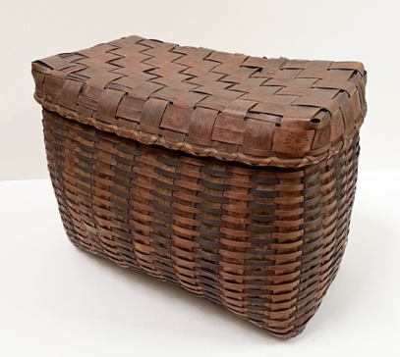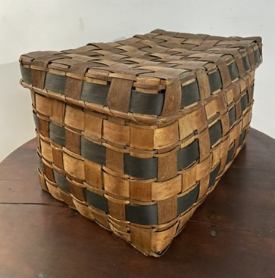
NEW PALTZ, NY (September 12, 2023) – New Paltz, NY – Historic Huguenot Street (HHS) presents a special exhibition, Indigenous Woodsplint Baskets, on view at the DuBois Fort Visitor Center, September 13 through December 17, 2023. Focusing on several fine examples from the HHS Permanent Collection, the exhibition highlights the story of Native American resilience and craftsmanship in New York and New England.

Formed by weaving thin strips of flexible wood made by pounding apart the growth rings of ash and other hardwood trees, splint baskets are often dyed, painted, and/or stamped for decorative and expressive purposes. The creation of woodsplint baskets in the late 18th and 19th centuries became a means for Native peoples of the Northeastern Woodlands to support themselves and their families after dispossession of their ancestral homelands and traditional ways of life. Ralph LeFevre’s History of New Paltz, published in 1909, includes first-hand accounts of the local Native people harvesting timber and making baskets in the area in the early 19th century.

In preparation for the exhibition, HHS applied for and was awarded funding from the NYSCA/GHHN Conservation Treatment Grant Program administered by the Greater Hudson Heritage Network to have one particular wicker-plaited splint basket conserved. The conserved basket features alternating natural and dark-stained splints for both the warps (verticals) and wefts (horizontals), as well a stamped motif on the lid. Conservation work performed on the basket by A.M. Art Conservation, LLC consisted of stabilizing and repairing areas where splints had broken or were lost, as well as cleaning to better reveal the original color and stamped designs. The grant program is made possible with public funds from the New York State Council on the Arts, with the support of the Office of the Governor and the New York State Legislature.

The exhibition is free and open to the public. The DuBois Fort Visitor Center is located at 81 Huguenot Street in New Paltz, New York. Hours through Halloween are Wednesdays through Sundays: 10 am-4 pm, with a break from 1 pm-2 pm to allow for the staff to take lunch (Closed Mondays and Tuesdays). Starting November 1, hours are on weekends only.

Images:
Covered Storage Basket (1179.1) from the HHS Permanent Collection, conserved with funds from the GHHN Conservation Treatment Program.
Covered Storage Basket (1177.1) from the HHS Permanent Collection.

About Historic Huguenot Street
A National Historic Landmark District, Historic Huguenot Street (HHS) is a 501(c)3 non-profit dedicated to preserving a pre-Revolutionary Hudson Valley settlement and engaging diverse audiences in the exploration of America's multicultural past, in order to understand the historical forces that have shaped America. As an educational institution founded by the town’s French-speaking Protestant descendants and chartered by the University of the State of New York Department of Education, HHS explores the lives of the early European colonists, honors the region’s Indigenous people, and acknowledges the enslaved and disenfranchised peoples who built this place. Today, HHS is recognized as an innovative museum and community gathering place, providing visitors with an inclusive presentation of our shared past. For more information visit www.huguenotstreet.org.
###
Sarah Levy
Marketing & Communications Coordinator
media@huguenotstreet.org
(845) 255-1660 Ext. 102

