“The Old Village” ca. 1830 on View at Historic Huguenot Street
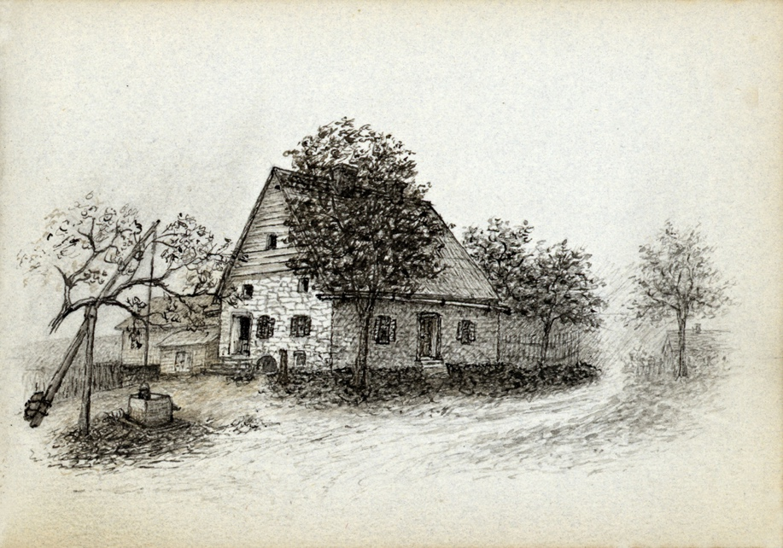
NEW PALTZ, NY (July 17, 2023) – Historic Huguenot Street (HHS) presents the exhibition The Old Village, currently on view through August 31, 2023 at the DuBois Fort Visitor Center. The exhibition focuses on the changing neighborhood of Huguenot Street as major developments in the New Paltz community were taking place in the years surrounding 1830.
By the 1830s, the original patentee families had expanded, most descendants moving outside the early settlement, throughout the town of New Paltz, and beyond. New families of European descent began to arrive and establish themselves and their families in the community. New York’s legal, yet gradual, abolition of slavery, by this time, meant that some people of African descent could establish their own households nearby (albeit on the outskirts), while many continued to labor as servants, sometimes indentured, in the households and on the farms of their enslavers. At this time, the center of local commerce was shifting from the “old village”—as Ralph LeFevre had called it—to the “Road to Plattekill” and to the new Turnpike, finished in the 1830s, that linked the community to the Hudson River and the larger region. Not surprisingly, New Paltz’s growing population demanded new and bigger churches and schools and a range of businesses. This exhibition explores the stories of the evolving neighborhood that formed around the original old village, its people, where they lived and worked, and their interactions.
This multi-cultural story is revealed through census records and original documents from the Historic Huguenot Street Archives, as well as documents from the Town of New Paltz and Reformed Church of New Paltz Records and Haviland-Heidgerd Historical Collection, Elting Memorial Library.
The exhibition is free and open to the public. The DuBois Fort Visitor Center is located at 81 Huguenot Street in New Paltz. Hours are Wednesdays through Sundays: 10 am-4 pm, with a break from 1 pm-2 pm to allow for the staff to take lunch (Closed Mondays and Tuesdays).
Image Detail: Jean Hasbrouck House, late 1800s. Drawing by Alfred Hasbrouck. HHS Archives.
About Historic Huguenot Street
A National Historic Landmark District, Historic Huguenot Street (HHS) is a 501(c)3 non-profit dedicated to preserving a pre-Revolutionary Hudson Valley settlement and engaging diverse audiences in the exploration of America's multicultural past, in order to understand the historical forces that have shaped America. As an educational institution founded by the town’s French-speaking Protestant descendants and chartered by the University of the State of New York Department of Education, HHS explores the lives of the early European colonists, honors the region’s Indigenous people, and acknowledges the enslaved and disenfranchised peoples who built this place. Today, HHS is recognized as an innovative museum and community gathering place, providing visitors with an inclusive presentation of our shared past. For more information visit www.huguenotstreet.org.
###

Sarah Levy
Marketing & Communications Coordinator
media@huguenotstreet.org
(845) 255-1660 Ext. 102

