Historic Huguenot Street Presents:
Acquisitions & Re-acquisitions, an Exhibition
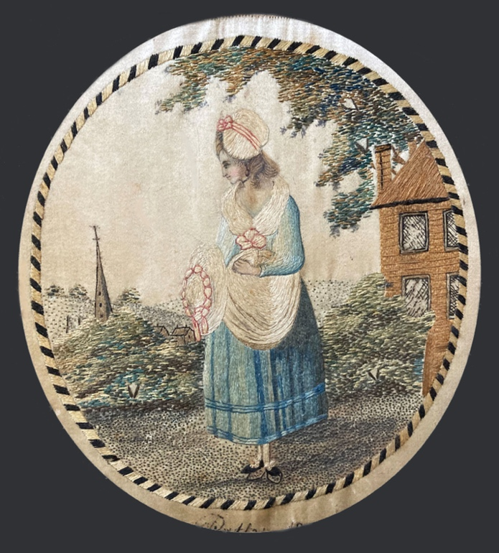. 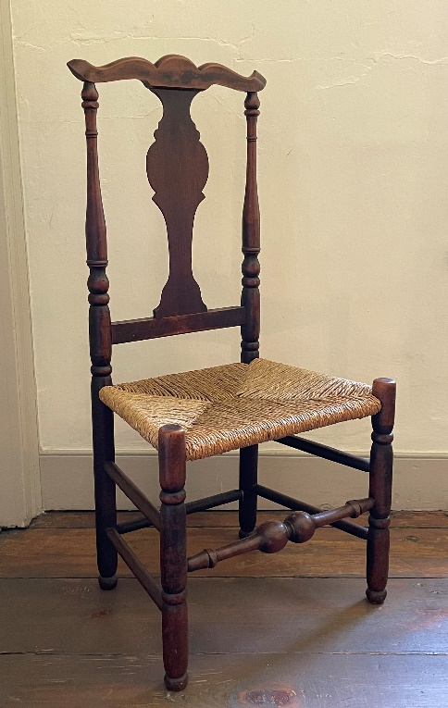

NEW PALTZ, NY (October 4, 2022) - Now on view, Historic Huguenot Street (HHS) is pleased to present the exhibition, Acquisitions and Re-acquisitions. With this special exhibition, HHS celebrates several important recent acquisitions (and re-acquisitions) to its Permanent Collection & Archives. Since 1894 and the formation of the Huguenot Patriotic, Historical, and Monumental Society, HHS has been collecting fine and decorative art, furniture, utilitarian objects, textiles, historical documents, and more, all to support the museum’s educational mission. Today, thousands of objects furnish Historic Huguenot Street’s historic stone houses, helping to illuminate the stories of the families who lived there. Other objects in the Permanent Collection are preserved for research and interpreted through exhibits, special programs, and social media posts.
The exhibition highlights important gifts from the John P. Strang Huguenot Heritage Collection, Anne C. Bienstock Collection, George H. Way Collection, and Richard Hasbrouck Estate, as well as a few museum purchases and long-hidden gems from the family holdings of Huguenot Street descendants. The exhibition also features two portraits by itinerant artist Ammi Phillips, stolen fifty years ago, which were recently recovered by the Federal Bureau of Investigation and returned to HHS.
The exhibit runs through December 18, 2022 and is located in the DuBois Fort Visitor Center. The Visitor Center is located at 81 Huguenot Street on HHS’s ten-acre National Historic Landmark District. Access to the Visitor Center is free and open to the public, Wednesday through Sunday, 10 am to 4 pm. After November 1, the Visitor Center is open Saturday and Sunday only. For more information about visiting the site, as well as general tours and other information, please go to www.huguenotstreet.org.

Image detail: Needlework inscribed “Patty / 1800” by Esther Bevier Hasbrouck (1785-1871). Silk with touches of watercolor. HHS Permanent Collection, gift of Bevier Hasbrouck; Side Chair, New York or Connecticut, late 18th century. HHS Permanent Collection, Anne C. Bienstock Collection.

About Historic Huguenot Street
A National Historic Landmark District, Historic Huguenot Street (HHS) is a 501(c)3 non-profit dedicated to preserving a pre-Revolutionary Hudson Valley settlement and engaging diverse audiences in the exploration of America's multicultural past, in order to understand the historical forces that have shaped America. As an educational institution founded by the town’s French-speaking Protestant descendants and chartered by the University of the State of New York Department of Education, HHS explores the lives of the early European colonists, honors the region’s Indigenous people, and acknowledges the enslaved and disenfranchised peoples who built this place. Today, HHS is recognized as an innovative museum and community gathering place, providing visitors with an inclusive presentation of our shared past. For more information visit www.huguenotstreet.org.
###
Sarah Levy
Marketing & Communications Coordinator
media@huguenotstreet.org
(845) 255-1660 Ext. 102

