Historic Huguenot Street Presents: Two “Hudson Valley Baroque” Fall Concerts
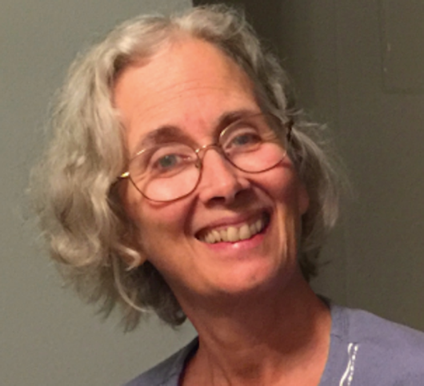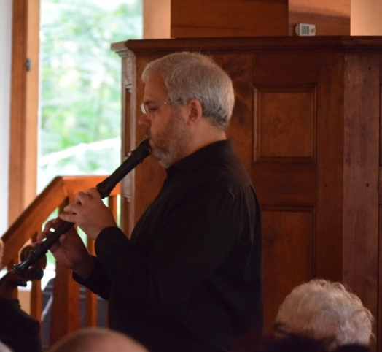
NEW PALTZ, NY (August 30, 2023) – Historic Huguenot Street (HHS) is proud to present two concerts this fall in partnership with the chamber ensemble, “Hudson Valley Baroque.”

At 4:00 PM on Sunday, September 10, 2023, at the French Huguenot Church in New Paltz, soprano Kathen Cowan will join "Hudson Valley Baroque" in a concert that includes historic Huguenot melodies and the music of Johann Sebastian Bach (1685–1750). The performers will also include Christiana Fortune Reader (violin/viola), Gregory Bynum (recorder), Joel Evans (oboe), Susan Seligman (cello), and Ruthanne Schempf (harpsichord).

At 4:00 PM on Sunday, October 1, 2023, at the French Huguenot Church in New Paltz, "Hudson Valley Baroque" will present a concert entitled “Northern Lights.” The performance will include music by the following composers: Jacob von Eyck (1590–1657), the blind, Dutch recorder virtuoso, campanologist, and carillon player; Joseph Bodin de Boismortier (1689–1755), a highly prolific composer of music for both public performance and amateur home enjoyment; and Johann Sebastian Bach (1685–1750), the great composer, keyboard virtuoso extraordinaire, and teacher. The performers will be Christiana Fortune Reader (violin/viola), Gregory Bynum (recorder), Joel Evans (oboe), Susan Seligman (cello), and Ruthanne Schempf (harpsichord).
For each concert admission will be $10 for general admission and $7 for discounted admission (for HHS members, seniors, students, veterans, active military members and their families, and children under 13). Admission is free for children under 6.

For more information, including the performers’ biographies and to register, please visit: https://www.huguenotstreet.org/calendar-of-events/2023/9/10/hudson-valley-baroque; or https://www.huguenotstreet.org/calendar-of-events/2023/10/1/northern-lights-hudson-valley-baroque

This program is made possible by the New York State Council on the Arts with the support of the Governor and the New York State Legislature.

Photo detail: 1. Soprano Kathen Cowen; 2. Recorder player and member of the “Hudson Valley Baroque” ensemble, Gregory Bynum.
About Historic Huguenot Street
A National Historic Landmark District, Historic Huguenot Street (HHS) is a 501(c)3 non-profit dedicated to preserving a pre-Revolutionary Hudson Valley settlement and engaging diverse audiences in the exploration of America's multicultural past, in order to understand the historical forces that have shaped America. As an educational institution founded by the town’s French-speaking Protestant descendants and chartered by the University of the State of New York Department of Education, HHS explores the lives of the early European colonists, honors the region’s Indigenous people, and acknowledges the enslaved and disenfranchised peoples who built this place. Today, HHS is recognized as an innovative museum and community gathering place, providing visitors with an inclusive presentation of our shared past. For more information visit www.huguenotstreet.org.
###

Sarah Levy
Marketing & Communications Coordinator
media@huguenotstreet.org
(845) 255-1660 Ext. 102

