Historic New Paltz Documents Translated with a Grant from the Dutch Consulate
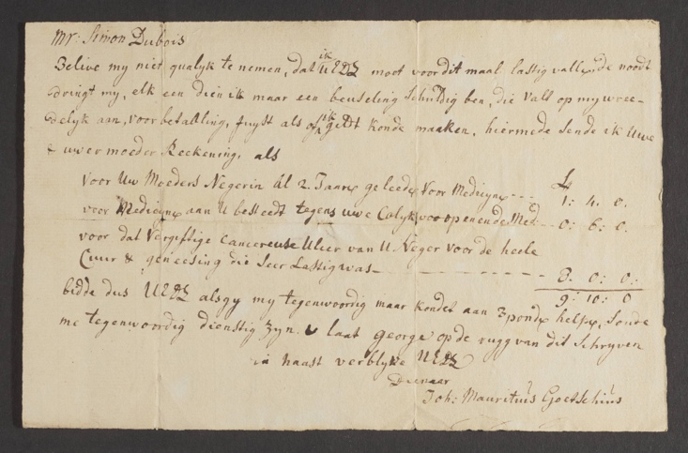
NEW PALTZ, NY (July 28, 2023) – Historic Huguenot Street (HHS) recently commissioned the translation of historic documents from Dutch to English, thanks to a grant of $25,000 as part of the Dutch Culture USA program by the Consulate General of the Netherlands in New York. The project encompasses early-American documents ranging from the mid-1600s through the 1700s, part of a larger project to digitize and make these documents available online with funding from the National Endowment for the Humanities (2021-24).

In order to complete the translation project, HHS enlisted noted New Netherland scholar and author Dr. Jaap Jacobs and his colleague Julie van den Hout. The team translated over 190 pages of these important early documents, drawn from the HHS Archives and the Reformed Church of New Paltz. Documents include the Second Register of the Reformed Church, which provides detailed insight into the religious lives of New Paltz residents. Translations for the Register are presented adjacent to an image of the original document, highlighting the layout of the corresponding handwritten text.

According to Dr. Jaap Jacobs, “The new translations will be much appreciated by scholars as well as genealogists, not least because the spelling of personal names has in many cases been corrected. The new translation also makes accessible many documents that had previously been left untranslated, for instance consistory minutes regarding a quarrel that had arisen between two church members and a letter with the request for financial assistance for an impoverished minister.”

Another category of the translated documents consists of financial records. While these would appear to be mundane, a closer look shows that an enormous amount of information about daily life in New Paltz during this period can be gleaned. For instance, these records indicate that New Paltz was well connected to the wider world: imported items such as tea, molasses, rum, and sugar are mentioned along with locally grown produce such as wheat, buckwheat, and corn. An account book kept by Hendricus DuBois Jr., with entries relating to making and repairing shoes and weaving wool and linen, paints a picture of the domestic lives of various families within the New Paltz community. Another document, a doctor’s bill, shows that David Deyo received medical attention for his neck in 1755. Importantly, another document reveals instances involving enslaved people of African descent receiving medical care, for which their enslaver, Simon DuBois of New Paltz, was charged.

“We’re extremely grateful to the Consulate General of the Netherlands for supporting this effort,” said Josephine Bloodgood, HHS Director of Curatorial and Preservation Affairs. “Having these documents translated from the old Dutch to modern English makes the information they contain more available to a much wider audience and enables us to tell a much more inclusive and accurate history of New Paltz.”

These and other documents may be explored online through the New York Heritage landing page for the New Paltz Historic Documents project at https://nyheritage.org/collections/new-paltz-historic-documents.

Image Caption:
Demand for payment, circa 1770, in Dutch for Simon DuBois to cover medical expenses, including care administered to Simon’s “mother’s Negro woman” and “that poisonous cancerous ulcer of your Negro, for the whole course and healing which was very difficult.”
About Historic Huguenot Street
A National Historic Landmark District, Historic Huguenot Street (HHS) is a 501(c)3 non-profit dedicated to preserving a pre-Revolutionary Hudson Valley settlement and engaging diverse audiences in the exploration of America's multicultural past, in order to understand the historical forces that have shaped America. As an educational institution founded by the town’s French-speaking Protestant descendants and chartered by the University of the State of New York Department of Education, HHS explores the lives of the early European colonists, honors the region’s Indigenous people, and acknowledges the enslaved and disenfranchised peoples who built this place. Today, HHS is recognized as an innovative museum and community gathering place, providing visitors with an inclusive presentation of our shared past. For more information visit www.huguenotstreet.org.
###

Sarah Levy
Marketing & Communications Coordinator
media@huguenotstreet.org
(845) 255-1660 Ext. 102

