Historic Huguenot Street Presents:
Haunted Huguenot Street
A Spooky, Theatrical Tour Through Time
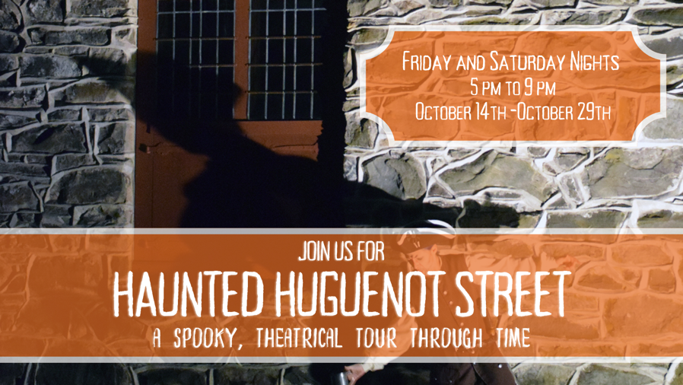
NEW PALTZ, NY (October 7, 2022) – Historic Huguenot Street (HHS) welcomes visitors to this year's Haunted Huguenot Street event: a spooky, theatrical tour through time. Led by spirits of the New Paltz community, happy haunts, and ghoulish ghosts, this journey will guide guests through some of HHS’s former residents’ forgotten pasts.
The tour will take visitors into three historic structures. First, the 1717 reconstructed French Church, which holds a New Paltz schoolmaster from 1730 whose spirit haunts the village until his dying wish is granted. Next, visitors will witness firsthand the long-fabled curse on the Deyo House, coming face-to-face with one of its most mysterious hauntings. Lastly, guests will step back in time into the dining room of the Old Fort Restaurant where they’ll meet an old friend eager to impart lessons learned from the town’s storied past.
Haunted Huguenot Street will run from 5:00 PM to 9:00 PM, Friday and Saturday nights, from October 14th-October 29th. The cost for pre-registered tickets will be $25 for general admission and $20 for discounted admission (for HHS members, seniors, students, active and retired military personnel, and children under 13). Children under 6 will receive free admission. Those expecting to register upon arrival on the evening of the tour will be charged a flat fee of $30 per registrant, space permitting.

This program is made possible by the New York State Council on the Arts with the support of the Governor and the New York State Legislature.

About Historic Huguenot Street
A National Historic Landmark District, Historic Huguenot Street (HHS) is a 501(c)3 non-profit dedicated to preserving a pre-Revolutionary Hudson Valley settlement and engaging diverse audiences in the exploration of America's multicultural past, in order to understand the historical forces that have shaped America. As an educational institution founded by the town’s French-speaking Protestant descendants and chartered by the University of the State of New York Department of Education, HHS explores the lives of the early European colonists, honors the region’s Indigenous people, and acknowledges the enslaved and disenfranchised peoples who built this place. Today, HHS is recognized as an innovative museum and community gathering place, providing visitors with an inclusive presentation of our shared past. For more information visit www.huguenotstreet.org.
###

Sarah Levy
Marketing & Communications Coordinator
media@huguenotstreet.org
(845) 255-1660 Ext. 102

